*Hello and welcome to the Office of Undergraduate Research, we are happy to introduce you to research at UCF. This document is a resource to aid students looking for research that they may be interested in, it is not a comprehensive guide; it is list of links so that students may begin their search.*

**Finding a pre-existing position**

The link below is a database of all of the posting labs have put up for taking in new researchers. The website can give you an idea of what research is being done, though this is not representative of ALL of the research being done at UCF. Please note that students receive the access code by attending a How to: Get Started in Undergraduate Research workshop or meeting with an OUR Peer Mentor. Thus you must be registered in UCF and attend this workshop prior to utilizing this link fully.

<https://academicsuccess.ucf.edu/our/prospective/positions/>

The following pages of links is in order of college and then departments within said college. The college website can be used to get a general sense of what research initiatives and college wide programs there are, as well as some of the primary labs. Then within the departments you will see more information regarding specific types of labs offered per department as well as professor information. Here you can figure out what lab or professor is doing research on what topics, so you can narrow down your search. Please note that you do not have to be within the department’s major in order to apply, research is highly multi-interdisciplinary and labs will often take students with different backgrounds and skillsets.

Additionally, in the case that that this is viewed on its own and without a OUR representative there is a couple of things that OUR would like for students to keep in mind while considering research.

* Research is not a gatekept opportunity, even if you do not feel you have the qualifications to engage in research, we encourage you to contact a professor or lab despite that feeling.
* Research is vast and varied, though there may not be a perfect fit for you, there are still opportunities to host your own research project, be it faculty sponsored or directly proposed under a lab.
* All professors/faculty/peers should be treated with respect, emails will not always be responded to immediately. In the case of that, please do a follow-up email after a reasonable amount of time, which could be anywhere from a few days to a week. It is polite to avoid contacting professors/faculty/peers on a weekend.
* To avoid making mistakes, please read up on a lab’s or professor’s papers prior to getting involved as even though the result of their research may be appealing, the process of conducting research may not appeal to all.

**College of computer science and engineering**

https://www.cecs.ucf.edu/

Department of Civil, Environmental and Construction Engineering - <https://www.cece.ucf.edu/centers-and-labs/>

Department of Computer science- <https://www.cs.ucf.edu/#research-areas>

Department of Electrical and Computer Engineering- <https://www.ece.ucf.edu/#research-areas>

Department of industrial engineering and management systems- <https://iems.ucf.edu/research/areas-of-research/>

Department of Material Science and Engineering- <https://mse.ucf.edu/lab-directory/>

Department of Mechanical and aerospace engineering- <https://mae.ucf.edu/lab-directory/>

**College of medicine**

<https://med.ucf.edu/research/>

Burnett school of biomedical sciences- <https://med.ucf.edu/biomed/>-

**College of Health Professions and Sciences**

Faculty- <https://healthprofessions.ucf.edu/research/faculty/>

<https://healthprofessions.ucf.edu/research/labs/>

**College of Arts and Humanities**

<https://cah.ucf.edu/research/>

**College of optics and photonics**

https://creol.ucf.edu/research/centers/

https://creol.ucf.edu/research/

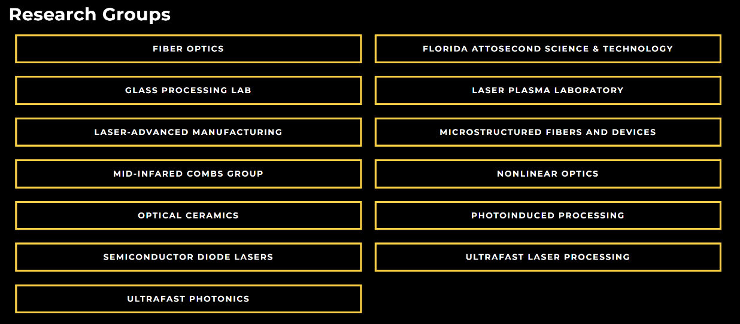

**College of Business**

<https://business.ucf.edu/faculty-research/#Office-of-Research-Contacts>

https://business.ucf.edu/faculty-research/research-areas/

**College of Sciences**

Department of Anthropology- <https://sciences.ucf.edu/anthropology/>

Department of Biology- <https://sciences.ucf.edu/biology/research/>

Department of Chemistry- <https://sciences.ucf.edu/chemistry/research/research-areas/>

Department of mathematics- <https://sciences.ucf.edu/math/undergraduate/opportunities/>

Department of physics- <https://sciences.ucf.edu/physics/research/>

Department of Psychology- <https://sciences.ucf.edu/psychology/research/laboratories/>

Department of Sociology- <https://sciences.ucf.edu/sociology/research/> ://ucf.discovery.academicanalytics.com/?unitId=18363&unitType=2